**Technical foundation**

**Comforty**

(General E-commerce Website)

* **Overview:**

Comforty is an innovative online furniture marketplace designed to offer customers a seamless shopping experience with high-quality furniture and customizable options. Leveraging modern technologies such as Next.js for the frontend, Sanity CMS for backend data management, and third-party APIs for payment and shipping, Comforty ensures a robust, scalable, and user-friendly platform.

* **Front-End Requirements:** 
  1. A user friendly interface for product browsing
  2. Responsive design for mobile and desktop users
  3. Essential pages:
* Home Page
* Products
* Product Page
* About
* Questions
* Cart
* Contact Us
* Privacy Policy
* **Back-End Requirements:**

1. We will use Sanity CMS to manage our product data, Customer details and Order records, shipment details.

* **Third-Party API’s:**

1. We will use mock API’s for our website data.
2. Integrate third party API’s for shipment tracking, payment gateway,

And other required services.

* 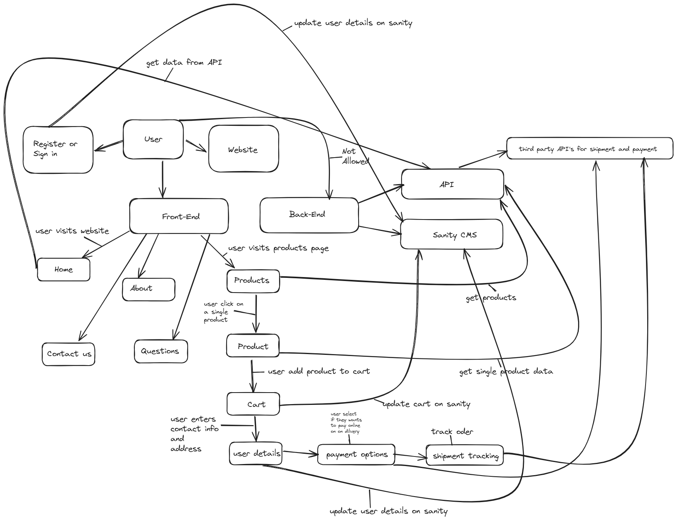**System Architecture:**
* **Workflows:**

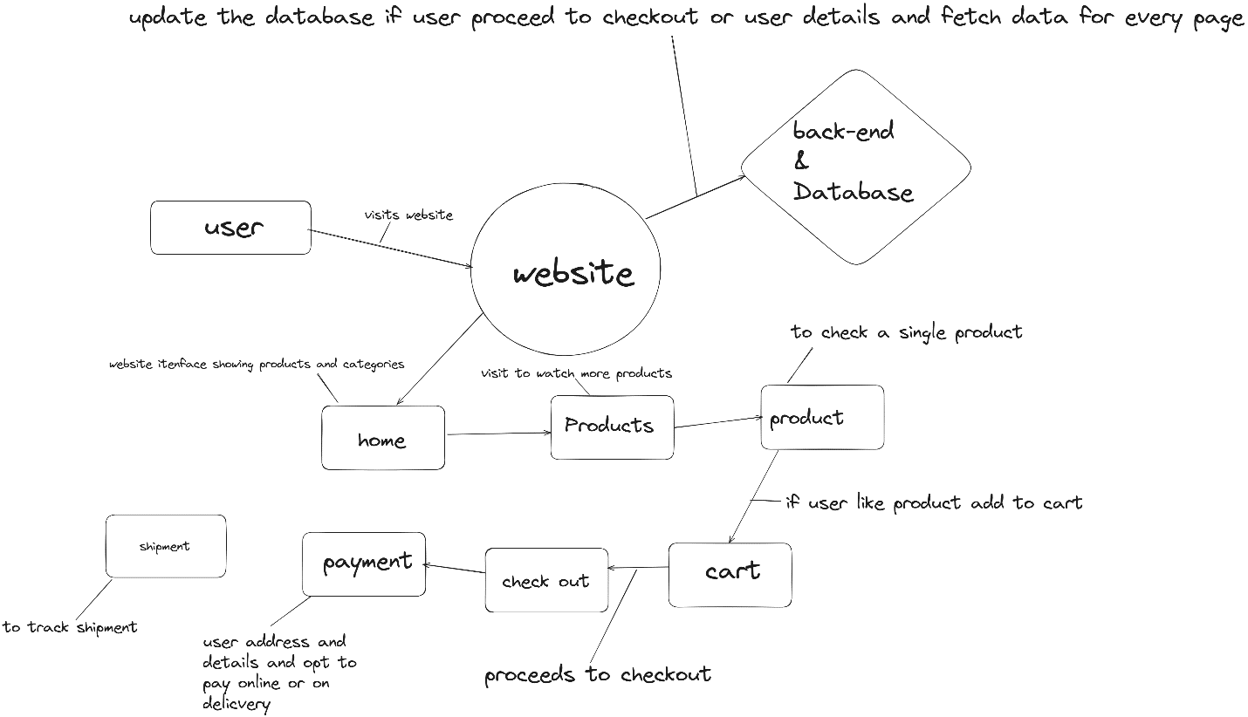

* **Product Browsing:** the user visits website the using the /products endpoint the data is being displayed on the page.
* **For specific Product:** user likes a specific product. The product id is return to show that specific product price details on the page.
* **Cart:** user likes the product and wants to buy it so user add it to the cart using the endpoint /cart/add.
* **API Endpoints:**

|  |  |  |  |
| --- | --- | --- | --- |
| **Endpoint** | **method** | **purpose** | **response** |
| /products | GET | Fetch all products | {“id” : 1,”name”:”product a”,”price”:160 ,……….} |
| /products/:id | GET | Fetch details of a product by id | {“id” : 1,”name”:”product a”,”price”:160} |
| /categories | GET | Fetch all categories | [ { "id": 1, "name": "Electronics" }, { "id": 2, "name": "Fashion" } ] |
| /categories/:id | GET | Fetch category of a product by id | { "id": 1, "name": "Electronics" }, |
| /products | POST | Add new item | Added successfully |

* **Sanity Schema:**

export const product = {

name: "product",

title: "Product",

type: "document",

fields: [

{

name: "id",

title: "ID",

type: "string",

},

{

name: "name",

title: "Name",

type: "string",

},

{

name: "description",

title: "Description",

type: "string",

},

{

name: "image",

title: "Image",

type: "image",

},

{

name: "price",

title: "Price",

type: "number",

},

{

name: "stock",

title: "Stock",

type: "number",

},

{

name: "category",

title: "Category",

type: "string",

},

],

};